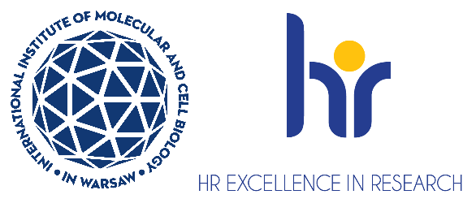

# PhD student position in the Laboratory of Iron Homeostasis

The Laboratory of Iron Homeostasis <https://shorturl.at/bEAXg> at the International Institute   
of Molecular and Cell Biology in Warsaw, headed by Katarzyna Mleczko - Sanecka, PhD, is looking   
for a **PhD student**.

You will join the project entitled “Identifying unique adaptive responses of red pulp macrophages   
to iron deficiency” carried out as the Sonata Bis grant (2020/38/E/NZ4/00511) of the National Science Centre, Poland led by Dr Katarzyna Mleczko – Sanecka.

**Aim of the project:** Within this project, we will apply both in vivo and in vitro approaches to further decipher the role of newly identified metabolic adjustments, particularly in amino acid utilization and catabolism, in the modulation of RPM phagocytic activity. We will also explore whether these metabolism-driven regulatory mechanisms extend to the control of efferocytosis, the general process of apoptotic cell clearance. This work is expected to advance our understanding of, and specialization in, the metabolic control of efferocytosis.

As a **PhD student,** you will be responsible for studies using mice and primary macrophages which will aim to identify specific roles of selected amino acids in the control of erythrophagocytosis and efferocytosis. Your role will also include conducting literature reviews to contextualize your findings, actively participating in lab meetings, presenting your work at national and international conferences, and contributing to the writing of research publications and your PhD thesis.

### **The admissions process is conducted through the Doctoral School website system. The PhD student can apply to this specific project carried out as part of the Warsaw-4-PhD doctoral school via website** <https://shorturl.at/cJKQY> **(the application system will be activated from** **19th of May 2025; deadline for sending application** **is 1st of June, 2025).** For more information, please follow the link <https://shorturl.at/mvxOR>

Candidates will be selected according to the procedure complying the rules for granting scholarships for young scientists in research projects funded by the National Science Centre (NCN Council Resolution No. 25/2019 dated March 14, 2019 r.), recruitment procedure for the Warsaw-4-PhD and the procedure complying with the rules of the European Charter for Researchers and the Code of Conduct for the Recruitment of Researchers as a part of HR Excellence in Research Strategy <https://bit.ly/3U0dydP>

**Requirements for the candidate:**

* Holds a Master's degree in biology, biochemistry or related field
* Eligibility for PhD studies in Poland
* Interests in molecular aspects of physiology, motivation for experimental work, passion for science, hands-on experience in laboratory work
* Experience in mouse/rat-based studies or willingness to work with animals
* Written and spoken fluency in English
* Willingness to learn and take on new challenges, ability to work independently, analytical thinking
* Good interpersonal skills and a collaborative attitude
* Research achievements (eg, publications or manuscripts in preparation) and experience abroad will be of advantage

**We offer:**

1. Full-time PhD scholarship 4 years (8 semesters) in amount:

a) before the mid-term evaluation 4800 pln net/month;

b) after mid-term evaluation 5300 pln net/month

1. Position with 100% focus on research (no teaching obligations)
2. Benefits including reduced-rate for an individual private medical care package   
   and membership in MultiSport programme
3. Full technical, administrative and organizational support from professional English-speaking personnel
4. Participation in courses, scientific training, support from peers, and academic mentoring

Deadline for applications is **1st of June, 2025.** The winter semester at the Doctoral School shall begin on **1st of October, 2025.**

**How to apply:**

* Apply via website <https://shorturl.at/cJKQY> (the application system will be activated from   
  19th of May, 2025; deadline for sending application is 1st of June, 2025). If you have   
  any enquiries about the recruitment process or the project, please send your request   
  to [kmsanecka@iimcb.gov.pl](mailto:kmsanecka@iimcb.gov.pl)
* Please include the following statement in your email: *“I hereby agree to the processing   
  of my personal data, included in the application documents by the International Institute of Molecular and Cell Biology in Warsaw, 4 Księcia Trojdena Street, 02-109 Warsaw, for the purpose of carrying out the* *current recruitment process.”* Your personal data will be processed for the purpose of the recruitment procedure by the International Institute of Molecular and Cell Biology in Warsaw. Full information is available under the link <https://bit.ly/3UFWpY2>
* Procedure for reporting irregularities, taking follow-up actions, and protecting whistleblowers: <https://shorturl.at/u2mww>

